**INTRODUCTION TO C PROGRAMMING**

TITLE : AIRLINE RESERVATION SYSTEM

NAME : NITESH REDDY & NITIN KOSHY

LECTURER : SHANTHA KUMARI

**Table of Contents:**

| *Content* |
| --- |
| Introduction |
| Assumptions |
| Design |
| Pseudo code |
| Implementation |
| Screenshots of system |
| C source code |
| Conclusion |

**Introduction:**

Originally, C language is developed from two previous languages, BCPL and B. BCPL which were developed in 1967 by Martin Richards as a language for wring operating systems and compilers. C was evolved from B by Dennis Ritchie at Bell Laboratories and it was implemented in 1972. It initially became widely known as the development language of the UNIX operating system. Lots of today’s leading operating systems are written in C and C++. C language is mostly hardware independent as it is possible to write C programs that are portable to most computers.

Why we use c language C has been used successfully for each kind of programming problem thinkable from operating systems to spreadsheets to expert systems - and efficient compilers are accessible for machines ranging in power from the Apple Macintosh to the Cray supercomputers. the largest measure of C's success appears to be based on strictly sensible considerations:

The standard library concept;

the ease with those applications can be optimized by hand-coding isolated procedures;

a powerful and varied repertoire of operators;

the portability of the compiler;

ready access to the hardware once needed;

(tutorialspoint, 2014) (John, 2016)

**ASSUMPTIONS:**

It is assumed that the program is Airline Reservation Systems:

A small airline has just purchased a computer for its new automated reservation system. The owner has asked to program the new system in C. It is required to write a program to assign seats on each flight of the airlines only place (capacity: 15 seats). The program should never assign a seat which is already assigned. If there’s no seat available, then print the message " the flight is full ".

After the flight is full and someone want to cancel the booking, it is displaying enter your passport number you want to cancel it so after the passenger cancel it, the system directly free that place for someone who wants to book that seat.

Moreover, the system should bring a boarding pass indicating the persons' name, passport number and seat number as each seat is assigned, set the corresponding elements of array to indicate that seat is no longer available.

**Design:**

Main menu

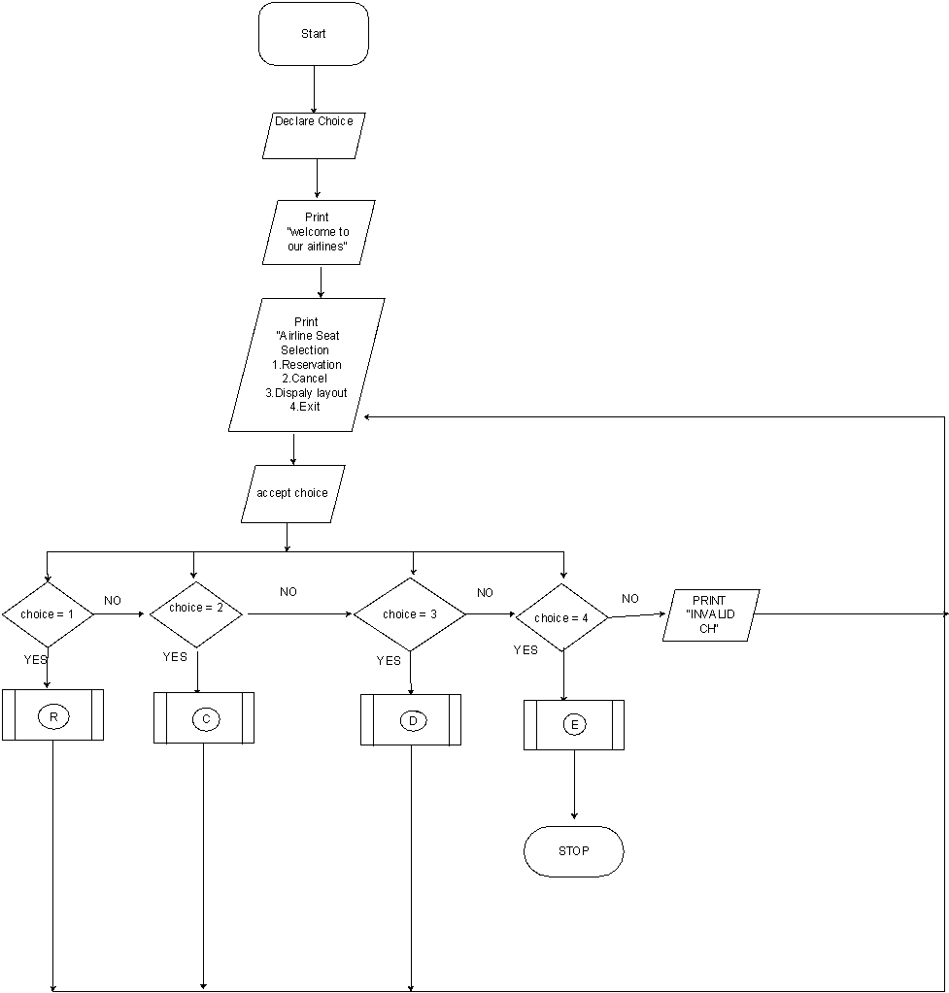

When the program is started, the user will direct to the main menu. The user is required to select one of the four options.

Reservation and cancel functions:

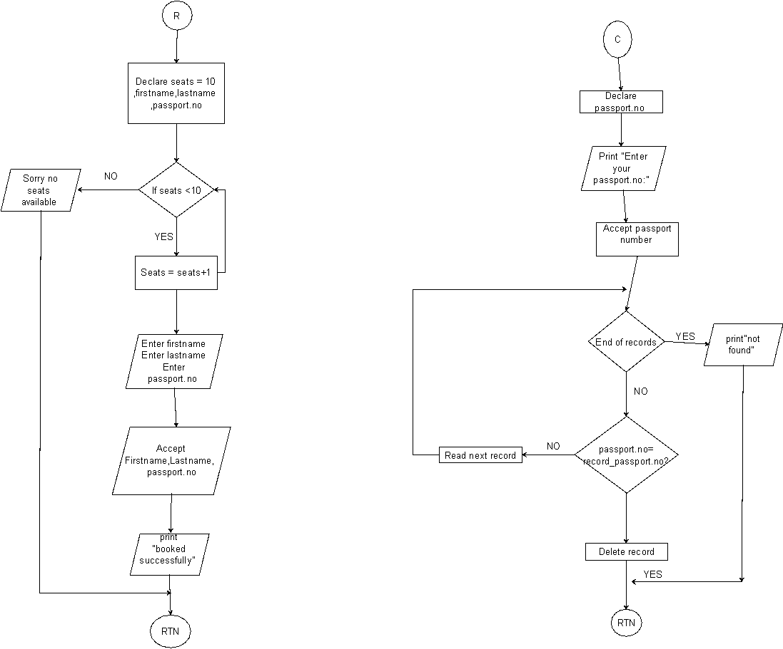

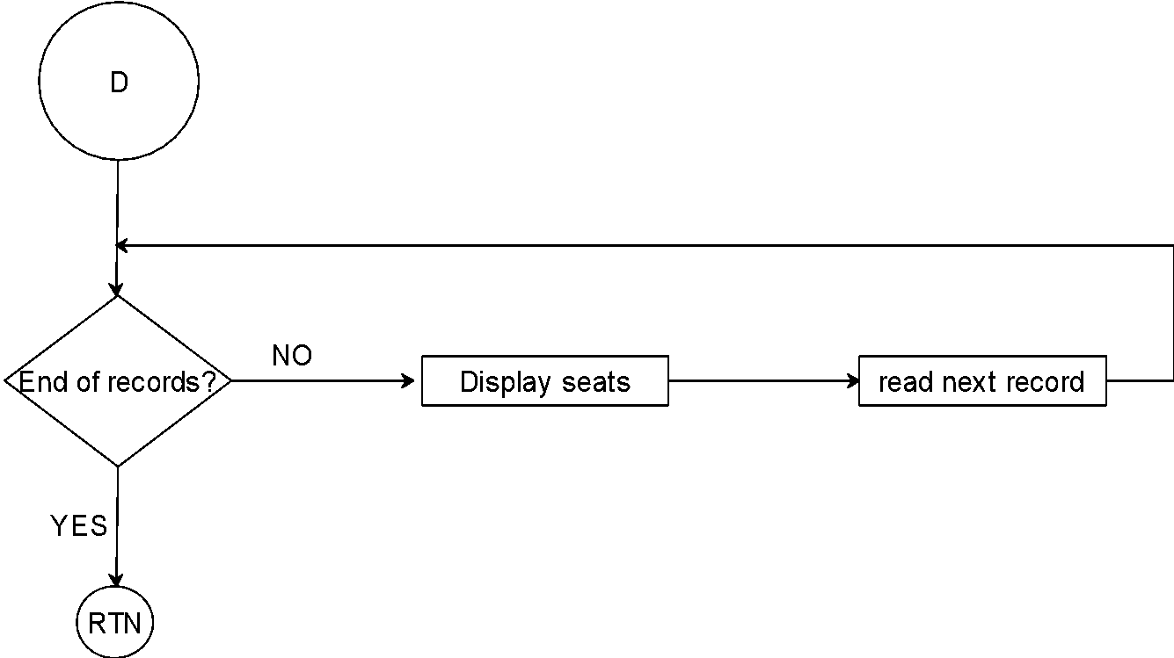

The above flow chart is for the displaying functions;

**Pseudocode:**

Begin

Declare Choice Repeat

repeat

display “welcome to our airlines”

display “Airline Seat Selection

1.Reservathion

2.Cancel

3.Dispaly layout

4.Exit

Enter your choice”

Accept choice

If (choice = 1)

Call R ()

Else

If (choice = 2)

Call C ()

Else

If (choice = 3)

Call D ()

Else

If (choice = 4)

Call E ()

Else

Print “Invalid choice”

End-If

End-If

End-If

End-If

Until (choice <> 4)

End

Function reservation ()

Declare passport number, name, nun, email, contact number

Print “Enter your passport number”

Accept passport number

Print “Enter your name”

Accept name

Print “Enter your email “

Accept email

Print “Enter your contact number”

Accept contact number

IF (seats >15)

Print No Seats Available

ELSE

IF

(Seats <=15)

Print “registered successfully”

END-IF

END-IF

END-FOR

Return

Function Cancel ()

Declare Passport number

Print “Enter passport number to delete record”

Accept passport number

Do while (not end of records)

IF (passport = record _passport)

Delete record

Return

END-IF

Read next record

END-do

print

Return

Function Display layout ()

Do while (not end of records)

Display Record

Read next record

End -do

Return

**Implementation:**

**(Header file)**

#include<stdio.h> (is a standard output function)

#include<stdlib.h> (Console Input Output)

#include<conio.h>

#include<string.h>

#include<Windows.h>

struct mufti_airline (Structures are used to represent a record)

{

char passport[6]; (Declaring)

char name[15];

int seat_num;

char email[15];

struct mufti_airline *following;

}

*begin, *stream;

struct mufti_airline *dummy;

#include<stdio.h> (is a standard output function)

#include<stdlib.h> (Console Input Output)

#include<conio.h>

#include<string.h>

#include<Windows.h>

struct mufti_airline (Structures are used to represent a record)

{

char passport[6]; (Declaring)

char name[15];

int seat_num;

char email[15];

struct mufti_airline *following;

}

*begin, *stream;

struct mufti_airline *dummy;

**Screenshots**

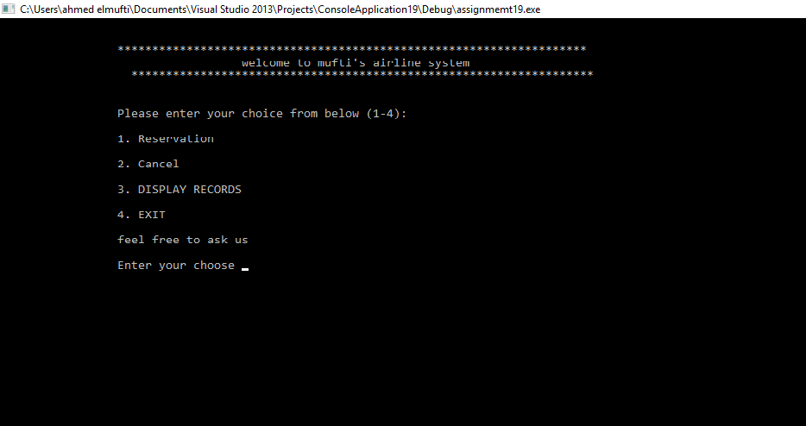

When the program is executed, the user will be directed to the main menu interface. The program is introduced with a few lines of texts. Then four selections are made for the user as the user can choose to reserve, cancel, display or exit the program.

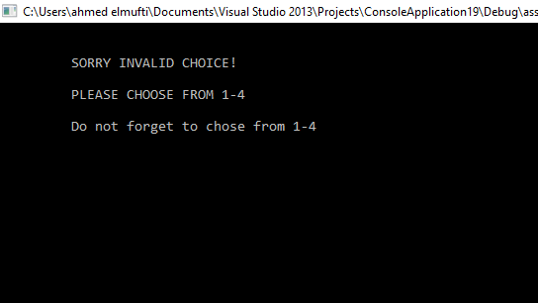

If the user accidentally enters an invalid input, an interface will be shown to notify the user to choose again and it notify the user again to enter from 1-4.

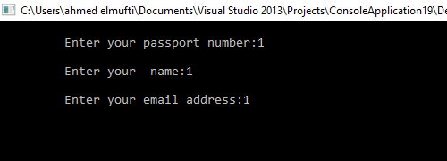

The program is asking the user to enter passport number, name, and the email address to reserve a seat for the user and the seat cannot be book for anyone else.

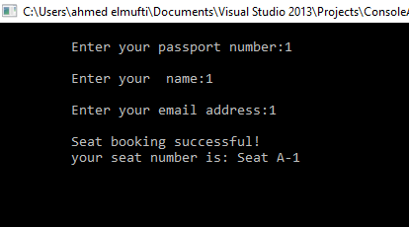

As shown in the interface the seat reservation has been booked successfully, after the user has entered the details.

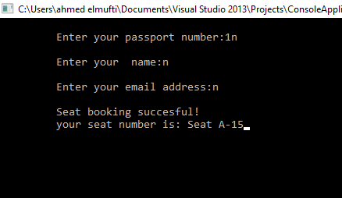

After registering 15 users in the system now the flight is supposed to be full and cannot accept anymore.

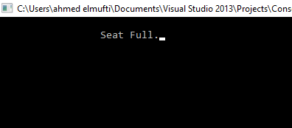

The system will pop out to notify the user that there’s no seat available, the flight contains only 15 seat after that it is displaying it is full sorry we cannot register anymore.

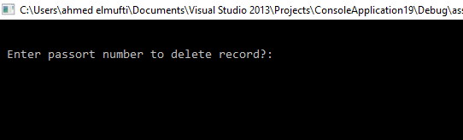

After the passenger entered 3 and want to cancel the record, after that, the program requires the user to enter which passport number to delete it. For example, that mufti registered the seat in the flight and he wants to cancel it.

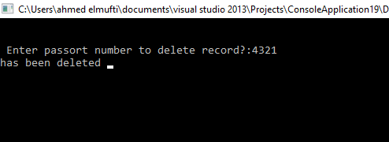

The system asking mufti to enter his passport number to cancel it from the system without any problems and in efficient way. After mufti entered his passport number the system pop in your record has been deleted from the system.

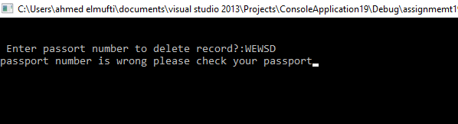

If mufti entered the wrong passport number by mistake the system pop in hey ahmed passport number is wrong, please check your passport number and enter it again.

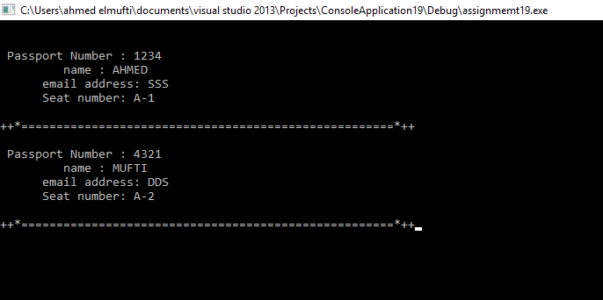

The interface is displaying all the users record that now you have two seats ahmed with his details and mufti with his details as well. There’s line between the users to make it clear to read and do not misunderstand it.

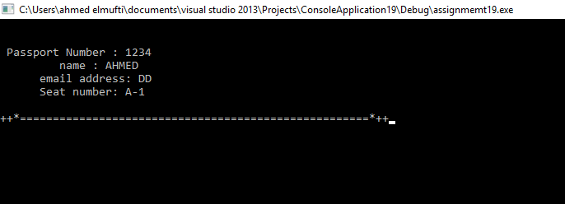

After mufti cancel his seat from the system, the interface is showing that only ahmed in the system and mufti’s seat already deleted.

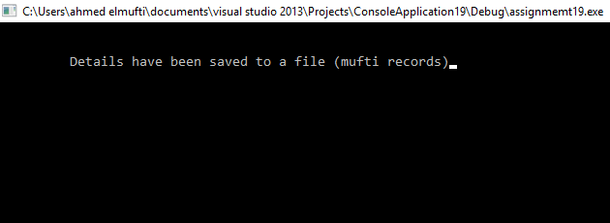

after entered 4 which is exit function, it is storing all the records into file with all the passenger’s details in mufti record.

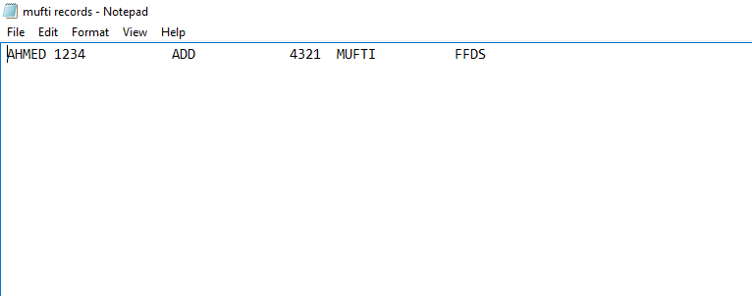

The interface is showing the record in notepad which is the storing part and it is displaying ahmed and his details after mufti cancel his record.

C source code :

#include<stdio.h>

#include<stdlib.h>

#include<conio.h>

#include<string.h>

#include<Windows.h>

struct mufti_airline

{

char passport[6];

char name[15];

int seat_num;

char email[15];

struct mufti_airline *following;

}

*begin, *stream;

struct mufti_airline *dummy;

void main()

{

void reserve(int x), cancel(), display(), savefile(); //function prototypes

int choice;

begin = stream = NULL; //initialize the struct pointers to NULL

int num = 1;

do

{

printf("\n\n\t\t ********************************************************************");

printf("\n\t\t welcome to mufti's airline system ");

printf("\n\t\t *******************************************************************");

printf("\n\n\n\t\t Please enter your choice from below (1-4):");

printf("\n\n\t\t 1. Reservation");

printf("\n\n\t\t 2. Cancel");

printf("\n\n\t\t 3. DISPLAY RECORDS");

printf("\n\n\t\t 4. EXIT");

printf("\n\n\t\t feel free to ask us");

printf("\n\n\t\t Enter your choose ");

scanf("%d", &choice); fflush(stdin);

system("cls");

switch (choice)

{

case 1:

reserve(num);

num++;

break;

case 2:

cancel();

break;

case 3:

display();

break;

case 4:

{

savefile();

break;

}

default:

printf("\n\n\t SORRY INVALID CHOICE!");

printf("\n\n\t PLEASE CHOOSE FROM 1-4");

#include<stdio.h>

#include<stdlib.h>

#include<conio.h>

#include<string.h>

#include<Windows.h>

struct mufti_airline

{

char passport[6];

char name[15];

int seat_num;

char email[15];

struct mufti_airline *following;

}

*begin, *stream;

struct mufti_airline *dummy;

void main()

{

void reserve(int x), cancel(), display(), savefile(); //function prototypes

int choice;

begin = stream = NULL; //initialize the struct pointers to NULL

int num = 1;

do

{

printf("\n\n\t\t ********************************************************************");

printf("\n\t\t welcome to mufti's airline system ");

printf("\n\t\t *******************************************************************");

printf("\n\n\n\t\t Please enter your choice from below (1-4):");

printf("\n\n\t\t 1. Reservation");

printf("\n\n\t\t 2. Cancel");

printf("\n\n\t\t 3. DISPLAY RECORDS");

printf("\n\n\t\t 4. EXIT");

printf("\n\n\t\t feel free to ask us");

printf("\n\n\t\t Enter your choose ");

scanf("%d", &choice); fflush(stdin);

system("cls");

switch (choice)

{

case 1:

reserve(num);

num++;

break;

case 2:

cancel();

break;

case 3:

display();

break;

case 4:

{

savefile();

break;

}

default:

printf("\n\n\t SORRY INVALID CHOICE!");

printf("\n\n\t PLEASE CHOOSE FROM 1-4");

printf("\n\n\t Do not forget to chose from 1-4");

}

getch();

} while (choice != 4);

}

void details()

{

printf("\n\t Enter your passport number:");

gets(stream->passport); fflush(stdin); //reads a line from stdin and stores it into the string pointed

printf("\n\t Enter your name:");

gets(stream->name); fflush(stdin);

printf("\n\t Enter your email address:");

gets(stream->email); fflush(stdin);

}

void details();

void reserve(int x)

{

stream = begin;

if (begin == NULL)

{

// first user

begin = stream = (struct mufti_airline*)malloc(sizeof(struct mufti_airline));

details();

stream->following = NULL;

printf("\n\t Seat booking successful!");

printf("\n\t your seat number is: Seat A-%d", x);

stream->seat_num = x;

return;

}

else if (x > 15) // FULL SEATS

{

printf("\n\t\t Seat Full.");

return;

}

else

{

// next user

while (stream->following)

stream = stream->following;

stream->following = (struct mufti_airline *)malloc(sizeof(struct mufti_airline));

stream = stream->following;

details();

stream->following = NULL;

printf("\n\t Seat booking succesful!");

printf("\n\t your seat number is: Seat A-%d", x);

stream->seat_num = x;

return;

}

}

void savefile()

{

FILE *fpointer = fopen("mufti records", "w");

if (!fpointer)

{

printf("\n Error in opening file!");

return;

Sleep(800);

}

stream = begin;

while (stream)

{

fprintf(fpointer, "%-6s", stream->passport);

fprintf(fpointer, "%-15s", stream->name);

fprintf(fpointer, "%-15s", stream->email);

stream = stream->following;

}

printf("\n\n\t Details have been saved to a file (mufti records)");

fclose(fpointer);

}

void display()

{

stream = begin;

while (stream)

{

printf("\n\n Passport Number : %-6s", stream->passport);

printf("\n name : %-15s", stream->name);

printf("\n email address: %-15s", stream->email);

printf("\n Seat number: A-%d", stream->seat_num);

printf("\n\n++*=====================================================*++");

stream = stream->following;

}

}

void cancel()

{

stream = begin;

system("cls");

char passport[6];

printf("\n\n Enter passort number to delete record?:");

gets(passport); fflush(stdin);

if (strcmp(begin->passport, passport) == 0)

{

dummy = begin;

begin = begin->following;

free(dummy);

printf(" booking has been deleted");

Sleep(800);

return;

}

while (stream->following)

{

if (strcmp(stream->following->passport, passport) == 0)

{

dummy = stream->following;

stream->following = stream->following->following;

free(dummy);

printf("has been deleted ");

getch();

Sleep(800);

return;

}

stream = stream->following;

}

printf("passport number is wrong please check your passport");

}

#include<stdio.h>

#include<stdlib.h>

#include<conio.h>

#include<string.h>

#include<Windows.h>

struct mufti_airline

{

char passport[6];

char name[15];

int seat_num;

char email[15];

struct mufti_airline *following;

}

*begin, *stream;

struct mufti_airline *dummy;

void main()

{

void reserve(int x), cancel(), display(), savefile(); //function prototypes

int choice;

begin = stream = NULL; //initialize the struct pointers to NULL

int num = 1;

do

{

printf("\n\n\t\t ********************************************************************");

printf("\n\t\t welcome to mufti's airline system ");

printf("\n\t\t *******************************************************************");

printf("\n\n\n\t\t Please enter your choice from below (1-4):");

printf("\n\n\t\t 1. Reservation");

printf("\n\n\t\t 2. Cancel");

printf("\n\n\t\t 3. DISPLAY RECORDS");

printf("\n\n\t\t 4. EXIT");

printf("\n\n\t\t feel free to ask us");

printf("\n\n\t\t Enter your choose ");

scanf("%d", &choice); fflush(stdin);

system("cls");

switch (choice)

{

case 1:

reserve(num);

num++;

break;

case 2:

cancel();

break;

case 3:

display();

break;

case 4:

{

savefile();

break;

}

default:

printf("\n\n\t SORRY INVALID CHOICE!");

printf("\n\n\t PLEASE CHOOSE FROM 1-4");

printf("\n\n\t Do not forget to chose from 1-4");

}

getch();

} while (choice != 4);

}

void details()

{

printf("\n\t Enter your passport number:");

gets(stream->passport); fflush(stdin); //reads a line from stdin and stores it into the string pointed

printf("\n\t Enter your name:");

gets(stream->name); fflush(stdin);

printf("\n\t Enter your email address:");

gets(stream->email); fflush(stdin);

}

void details();

void reserve(int x)

{

stream = begin;

if (begin == NULL)

{

// first user

begin = stream = (struct mufti_airline*)malloc(sizeof(struct mufti_airline));

details();

stream->following = NULL;

printf("\n\t Seat booking successful!");

printf("\n\t your seat number is: Seat A-%d", x);

stream->seat_num = x;

return;

}

else if (x > 15) // FULL SEATS

{

printf("\n\t\t Seat Full.");

return;

}

else

{

// next user

while (stream->following)

stream = stream->following;

stream->following = (struct mufti_airline *)malloc(sizeof(struct mufti_airline));

stream = stream->following;

details();

stream->following = NULL;

printf("\n\t Seat booking succesful!");

printf("\n\t your seat number is: Seat A-%d", x);

stream->seat_num = x;

return;

}

}

void savefile()

{

FILE *fpointer = fopen("mufti records", "w");

if (!fpointer)

{

printf("\n Error in opening file!");

return;

Sleep(800);

}

stream = begin;

while (stream)

{

fprintf(fpointer, "%-6s", stream->passport);

fprintf(fpointer, "%-15s", stream->name);

fprintf(fpointer, "%-15s", stream->email);

stream = stream->following;

}

printf("\n\n\t Details have been saved to a file (mufti records)");

fclose(fpointer);

}

void display()

{

stream = begin;

while (stream)

{

printf("\n\n Passport Number : %-6s", stream->passport);

printf("\n name : %-15s", stream->name);

printf("\n email address: %-15s", stream->email);

printf("\n Seat number: A-%d", stream->seat_num);

printf("\n\n++*=====================================================*++");

stream = stream->following;

}

}

void cancel()

{

stream = begin;

system("cls");

char passport[6];

printf("\n\n Enter passort number to delete record?:");

gets(passport); fflush(stdin);

if (strcmp(begin->passport, passport) == 0)

{

dummy = begin;

begin = begin->following;

free(dummy);

printf(" booking has been deleted");

Sleep(800);

return;

}

while (stream->following)

{

if (strcmp(stream->following->passport, passport) == 0)

{

dummy = stream->following;

stream->following = stream->following->following;

free(dummy);

printf("has been deleted ");

getch();

Sleep(800);

return;

}

stream = stream->following;

}

printf("passport number is wrong please check your passport");

}

stream = stream->following;

}

}

void cancel()

{

stream = begin;

#include<stdio.h>

#include<stdlib.h>

#include<conio.h>

#include<string.h>

#include<Windows.h>

struct mufti_airline

{

char passport[6];

char name[15];

int seat_num;

char email[15];

struct mufti_airline *following;

}

*begin, *stream;

struct mufti_airline *dummy;

void main()

{

void reserve(int x), cancel(), display(), savefile(); //function prototypes

int choice;

begin = stream = NULL; //initialize the struct pointers to NULL

int num = 1;

do

{

printf("\n\n\t\t ********************************************************************");

printf("\n\t\t welcome to mufti's airline system ");

printf("\n\t\t *******************************************************************");

printf("\n\n\n\t\t Please enter your choice from below (1-4):");

printf("\n\n\t\t 1. Reservation");

printf("\n\n\t\t 2. Cancel");

printf("\n\n\t\t 3. DISPLAY RECORDS");

printf("\n\n\t\t 4. EXIT");

printf("\n\n\t\t feel free to ask us");

printf("\n\n\t\t Enter your choose ");

scanf("%d", &choice); fflush(stdin);

system("cls");

switch (choice)

{

case 1:

reserve(num);

num++;

break;

case 2:

cancel();

break;

case 3:

display();

break;

case 4:

{

savefile();

break;

}

default:

printf("\n\n\t SORRY INVALID CHOICE!");

printf("\n\n\t PLEASE CHOOSE FROM 1-4");

printf("\n\n\t Do not forget to chose from 1-4");

}

getch();

} while (choice != 4);

}

void details()

{

printf("\n\t Enter your passport number:");

gets(stream->passport); fflush(stdin); //reads a line from stdin and stores it into the string pointed

printf("\n\t Enter your name:");

gets(stream->name); fflush(stdin);

printf("\n\t Enter your email address:");

gets(stream->email); fflush(stdin);

}

void details();

void reserve(int x)

{

stream = begin;

if (begin == NULL)

{

// first user

begin = stream = (struct mufti_airline*)malloc(sizeof(struct mufti_airline));

details();

stream->following = NULL;

printf("\n\t Seat booking successful!");

printf("\n\t your seat number is: Seat A-%d", x);

stream->seat_num = x;

return;

}

else if (x > 15) // FULL SEATS

{

printf("\n\t\t Seat Full.");

return;

}

else

{

// next user

while (stream->following)

stream = stream->following;

stream->following = (struct mufti_airline *)malloc(sizeof(struct mufti_airline));

stream = stream->following;

details();

stream->following = NULL;

printf("\n\t Seat booking succesful!");

printf("\n\t your seat number is: Seat A-%d", x);

stream->seat_num = x;

return;

}

}

void savefile()

{

FILE *fpointer = fopen("mufti records", "w");

if (!fpointer)

{

printf("\n Error in opening file!");

return;

Sleep(800);

}

stream = begin;

while (stream)

{

fprintf(fpointer, "%-6s", stream->passport);

fprintf(fpointer, "%-15s", stream->name);

fprintf(fpointer, "%-15s", stream->email);

stream = stream->following;

}

printf("\n\n\t Details have been saved to a file (mufti records)");

fclose(fpointer);

}

void display()

{

stream = begin;

while (stream)

{

printf("\n\n Passport Number : %-6s", stream->passport);

printf("\n name : %-15s", stream->name);

printf("\n email address: %-15s", stream->email);

printf("\n Seat number: A-%d", stream->seat_num);

printf("\n\n++*=====================================================*++");

stream = stream->following;

}

}

void cancel()

{

stream = begin;

system("cls");

char passport[6];

printf("\n\n Enter passort number to delete record?:");

gets(passport); fflush(stdin);

if (strcmp(begin->passport, passport) == 0)

{

dummy = begin;

begin = begin->following;

free(dummy);

printf(" booking has been deleted");

Sleep(800);

return;

}

while (stream->following)

{

if (strcmp(stream->following->passport, passport) == 0)

{

dummy = stream->following;

stream->following = stream->following->following;

free(dummy);

printf("has been deleted ");

getch();

Sleep(800);

return;

}

stream = stream->following;

}

printf("passport number is wrong please check your passport");

}

**Conclusion:**

The Airline reservation system is designed for users to reserve a seat, cancel, display seat and exit the system. A formula is included in the function to calculate the seats are reserved. Pseudocode is written for some important codes. A few flow charts are also created for explaining the process of the Airline reservation system.

From this assignment, I have learnt to implement a few C concepts in the future projects such as functions, switch statement and do…while statement, arrays, pointers and structures in the program.